Wall Wetting

Basics
Wall wetting refers to the fuel film or layer the forms on the walls of the manifold, port and intake valves during operation. At constant rpm and manifold pressure the film will be basically stable with fuel being added to the film at the same rate fuel is evaporating from the film. The film is thinnest at high vacuum/low pressure and high rpm and thickest at low vacuum/high pressure and low rpm. In most case at very high rpm (top 1/3 of the engines range) the film will be essentially zero as the port/runner air velocity is high and effectively strips all the fuel from the walls.

When the throttle is opened the pressure in the intake manifold goes up. If the engine is running on a liquid fuel such as gasoline then the some of the fuel will condense on the walls instead of remaining in the air stream and flowing into the cylinder creating a lean condition temporarily until equilibrium is reach. Conversely, if the throttle is closed the intake manifold pressure will drop and fuel that was inside the manifold in liquid form will evaporate creating a temporary rich condition until equilibrium is reached.

Solution.
The solution to the lean/rich condition that exists during throttle changes is to add or remove fuel from the injector pulse to compensate for the fuel that is going to or coming from the manifold/port walls until equilibrium is reached.

Traditionally this was done with an “accelerator pump” feature similar to the accelerator pump on a carburetor that added extra fuel as the throttle opened and a “decal fuel cut” that simply cut fuel during decelerations and these methods work to keep the engine running but they generally cannot maintain a controlled air/fuel ratio leading to reduced power and increased emissions.

A more effective approach is to map the fuel that is present as stored liquid in the manifold and track the current stored fuel then comparing the 2 values to determine how much to adjust the injector pulse so the engine receives the desired air/fuel ratio at all times. This is what the wall wetting function does.

How the model operates
Fuel_Wetting_Enable – This is a user variable with a value of 0/1 to enable the function when the value is 1.

Fuel_Wetting_Enbale_Time [s] – This is the run time before the wetting system enables, 0-120 seconds. Cranking and post-start can be somewhat difficult to predict and this variable allow the user to delay the wetting system operation to allow that region to be controlled with a separate function, Start_Adder

Fuel_Stored_Base [mg] – This is the fuel stored in a single representative manifold runner/port in milligrams during steady state operation at normal operation temperature. This is used as the basis for target or desired amount of fuel stored in the manifold/port calculation.

Fuel_Stored_CLT_Corr_Enable - This is a user variable with a value of 0/1 to enable the function when the value is 1.

Fuel_Stored_CLT_Corr [%] – When the manifold/port is cold more fuel will condense on the walls. If enabled this table allow the user to enter % correction to the Fuel_Stored based on Coolant Temperature.

Fuel_Stored_IAT_Corr_Enable - This is a user variable with a value of 0/1 to enable the function when the value is 1.

Fuel_Stored_IAT_Corr [%]– When the air is cold more fuel will condense on the walls. If enabled this table allow the user to enter % correction to the Fuel_Stored based on Inlet Air Temperature.

Fuel_Stored_Angle_Corr_Enable - This is a user variable with a value of 0/1 to enable the function when the value is 1.

Fuel_Stored_Angle_Corr [%] – The amount or time the fuel has to sit in the manifold/port can affect the amount condensed on the walls. If enabled this table allow the user to enter % correction to the Fuel_Stored based on Injection End Angle.

Fuel_Stored_Target [g] – The amount of fuel in grams that is stored on the manifold/port walls under current conditions during steady-state operation. It assumes that stored fuel is proportional to the target lambda and applies a lambda correction to the values in the Fuel_Stored_Base [mg] table along with the corrections for Coolant Temperature, Inlet Air Temperature, and Injection End Angle.

Fuel_Stored_Current [g] – The running total of fuel or fuel in grams that is currently stored in the manifold.

Fuel_Stored_Delta [mg] - The difference between Fuel_Stored_Target [g] and Fuel_Stored_Current [g] which is the basis for the missing or extra fuel required calculation

Fuel_Stored_Correction [%] – This is the correction to apply each engine cycle as a % of Fuel_Stored_Delta. It creates a proportional decay based on rpm and magnitude of the Fuel_Stored_Delta.

Fuel_Stored Correction [g] – This is the output of the function. It is a value in grams that should be added to the Fuel_Req [g] to correct for wall wetting effects. This is and addition not a % multiplication to a base fuel calculation because it is a function or manifold design and has little to do with other engine parameters.

Tuning Wall Wetting
Wall Wetting should be one of the last fuel corrections tuned, and should be disabled until other fuel tuning is complete.

Start by Disabling:
Fuel_Stored_CLT_Corr_Enable
Fuel_Stored_IAT_Corr_Enable
Fuel_Stored_Angle_Corr_Enable

These will be enabled and tuned if needed after the main Wall Wetting tuning is complete.

Leave the main Enable Fuel_Wetting_Enable function disabled for now too.

The first step is to measure the fuel that is stored in the manifold under different conditions to populate the Fuel_Stored_Base table. The table can have fairly large steps on the axis points as shown below. There is normally no need to apply corrections at very high rpm so scale you x-axis to make the highest rpm about 2/3-3/4 redline as a starting point, you can always add more columns later if you find you need them. The rpm points should start at 0 and Fuel_Wetting_Enbale_Time [s] should be 0 if you plan to use this function for cranking and post start enrichment or at idle rpm and Fuel_Wetting_Enbale_Time [s] set to begin about when the Start_adder function ends if you will be using the Starter_Adder function for that correction.

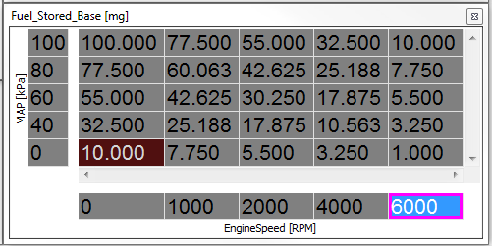

Before beginning get the engine up to normal operating temperate and also note the Inlet Air Temperature you are working at as this information will be helpful later if you find you need to enable and tune the Fuel_Stored_IAT_Corr.

- Bring the engine conditions as close as possible to centered on a cell in the Fuel_Stored_Base table.
- Shut down fuel to 1 of the cylinders and wait a few seconds, you will now see a very lean condition because the shut down cylinder to pumping air into the exhaust and the lambda sensor is reading the O2 in that air.
- Restart the fuel and watch the response on the lambda signal. At the time the fuel restarts the lambda signal will return to normal over some number of cycles (no change can occur until the injector fires so this is cycle based not time based)
- The fuel stored in the manifold/port is the integral of the lambda error from the time the fuel is restarted until the lambda signal returns to normal. Enter this value in the table
- Repeat steps 1-4 to complete all cells in the table

Set up the Fuel_Stored_Correction [%] table as show below

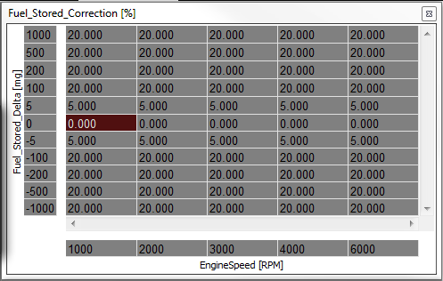

The x-axis shown goes from idle to 2/3 redline. If you want to use the wetting function to also handle cranking and post-start enrichment it should also have points near cranking rpm and your run threshold rpm.

The y-axis is Error in milligrams of fuel. The center of the table should be 0, this is the steady state condition where there is no error. The bottom ½ of the table should be negative values and happens when the throttle is opened. The top ½ are positive numbers and happens when the throttle is closed. The row top and bottom of the 0 row as basically a hysteresis or dead band where you want the system responding very slowing, 5 or 10 mg is a good starting point for these rows.

The cells in this table are the % correction of the difference between what sure be in the intake (Fuel_Stored_Target [g]) and what is in the intake (Fuel_Stored_Current [g]) to make each cycle. The cells on the 0 row should be 0. The cell top and bottom of the 0 row should be a low value, 5% is a good starting point as the goal with these rows is to damp the system.

The rest of the cells you will need to tune but set them all to 20% as a starting point then get the engine up to normal operating temperate and Enable Fuel_Wetting_Enable to begin.

Tuning this function is a little more difficult than most other functions because you cannot hold a constant Stored_Fuel_Delta. The best strategy is to run a log plot with rpm, MAP, Stored_Fuel_Delta, Stored_Fuel_Correction [%] and lambda. Then make changes to the table based on what you see in the log.

- Bring the engine to an rpm in your table and light load.
- Open the throttle and try to maintain a new higher load until the mixture returns to normal..
- If the mixture went lean then enter a larger % correction, if rich a smaller % correction in the appropriate cell(s)
- Repeat the test until you have a fairly constant mixture result. If you are able to get the mixture good at first but it’s lean no matter what at the end then the value you measure for stored fuel is too low and you’ll need to increase it and repeat the test, work 10% at a time. If the mixture is good then goes rich no matter what you do then the stored fuel value is too large and you’ll need to decrease it.
- Repeat 1-4 jumping to a higher load.
- Repeat 1-5 at each rpm point.
- Repeat 1-6 but now starting at a high load and stepping to low load. Do NOT alter the stored fuel table! that is tuned and should not be touched again. Change only the % corrections and understand that you can’t shorten the fuel pulse below 0 so it’s very possible that the mixture will go rich and there is nothing you can do short of redesigning the intake manifold to fix it. Get it the best you can.

Next the coolant correction will probably be required but obviously this can only be tuned when the engine is cold. Let the engine cool down fully and repeat steps 1-6 as the engine warms up. The table will look something like shown below.

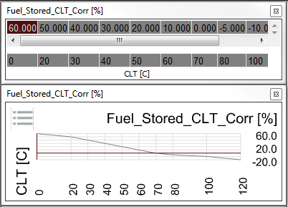

The Inlet Air Temperature correction may be required but this requires you have different air temperatures to try. You may be able to some cool early morning vs warm mid day, but normally this is tuned as the seasons change.

The Injection end correction is normally not needed because you will have set injection end angle prior to tuning wall wetting, but maybe needed if you have multiple injection end tables.

